Patients can now access their health records through the NHS App

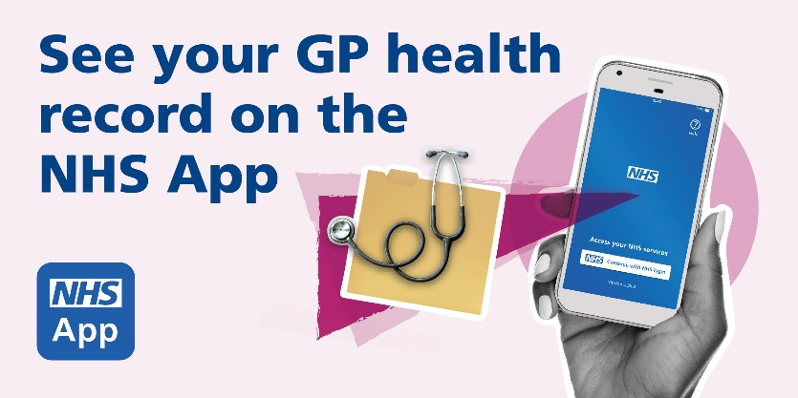

People over the age of 16 can now access their GP health record on the NHS App and nhs.uk. This includes consultation notes, letters and test results.
During your next visit to the surgery, ask at reception to find out more.
https://nhs.uk/helpmeapp

