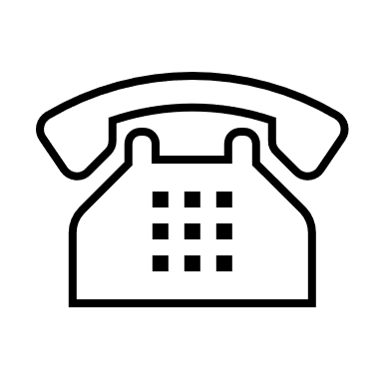
Telephone Line Closure

The main telephone line will be unavailable between 12.30pm and 1.30pm every day from Monday 29 November.

In cases of extreme emergency please continue to call 01793 688744 where your call will be diverted to a reception team member

Please note if your call is considered NOT to be an emergency you will be asked to call back after 1.30pm

The main telephone line will re-open at 1.30pm for routine queries, appointment booking etc

