Issue 4 – September 2020
Coronavirus Update
Work in General Practice had to change rapidly in March to ensure we could continue to provide a safe service to our patients, whilst managing staff and patients being in lockdown and ensuring that all staff at our practices were safe.
After several months of hard work and uncertainty we appear to have reached a stage where we are better organised and able to operate efficiently.
- We have had to organise ourselves quickly to enable key groups of staff to be able to work from home, with either laptops or PC’s.
- Discussing appointments with patients on the phone has become the main way of communication, which does bring its own challenges, and is a massive change for our clinicians.
- We have set up systems to enable clinicians to either be able to do video consultations or receive photographs of rashes or bites to enable them to consult with patients remotely and to make good clinical decisions for treatment.
- We have had to set up systems to enable patients and staff to feel safe on site including one way walkways and socially distanced waiting rooms. This has also meant analysing all appointments to ensure that we do not have too many patients on site at one time.
- We have risk assessed all our staff for the impact of contracting COVID-19 to ensure and changed their working practices accordingly.
- In March we set up a hot site, at Priory Road Medical Centre, for patients who had COVID symptoms, to ensure that we were not bringing patients into all 5 sites, who could potentially spread the virus to staff. This required the majority of staff to move out of Priory Road and work from another practice. This site has now been stepped down but we are ready to re-start this site if there is another outbreak in Swindon.
- PPE or Personal Protective Equipment has become a huge part of seeing patients now. All our clinics have had to be adjusted to enable our staff to have time to clean between patients, get gowned, masked and gloved up to ensure that they are safe, as well as our patients.

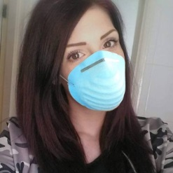
Flu Clinics
All 5 practices will be starting their flu clinics shortly. Information will be on our individual websites about when our clinics are running or telephone the surgery to book an appointment.
Due to COVID, our flu clinics will be running differently as we have to ensure that patients are socially distanced and that there is enough time to clean hands and rooms, between each patient so we can ensure your safety.

How to get an appointment?
We have had to change how we work in our surgeries so you must ring the practice to book an appointment. Due to most appointments being dealt with by telephone we have had to stop online bookings.
You must telephone to book an appointment. Please do not turn up at the surgery.

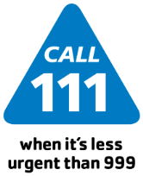 NHS 111 – if you are assessed and it is deemed that you need an appointment, this can be booked for you.

Doctor Link – this is a tool for patients to use to assess if they need an appointment with a doctor or nurse. You have to register for this service at www.doctorlink.com or download the app and then you can enter your symptoms and you will be advised if you need an appointment (which we will book for you).

For more information on any of the above services please ask our reception staff.

